A practice-based evaluation of the Voco GrandioSO

composite restorative system by the PREP Panel

F.J Trevor Burke, DDS, MSc, MDS, MGDS FDS (RCS Edin.), FDS RCS (Eng.), FFGDP(UK), FADM¹

Russell J Crisp, BDS, DGDP¹
Peter Sands, MSc, BDS, LDSRCS²

1. Primary Dental Care Research Group,

University of Birmingham School of Dentistry
St. Chad’s Queensway
Birmingham B4 6NN, UK
Voice: 0044 121 237 2767
Fax: 0044 121 237 2768
2. General Practitioner, St Helen’s Dental Practice
7 East St Helen Street

Abingdon OX14 5EG

Voice: 0044 121 237 2767
Fax: 0044 121 237 2768
Email f.j.t.burke@bham.ac.uk
REF:PREP GRANDIOSO Pub report 12.1.12

INTRODUCTION

Product under evaluation: 1. Voco GrandioSO
Description: Nano-Hybrid Composite restorative material
Manufacturer: Voco Gmbh
P.O. Box 767
27457 Cuxhaven
Germany
Website: http://www.voco.com/en

Practice based research

The importance of practice-based research has been emphasized by Mandel, who considered that “research is not only the silent partner in dental practice, it is the very scaffolding on which we build and sustain a practice”¹.
A wide variety of research projects may be considered to be appropriate to general dental practice, including², the assessment of materials and techniques and clinical trials of materials. Indeed, it could further be considered that dental practice is the most appropriate theatre for such research, given that it is the “real world” where the majority of restorative dental treatment is carried out, worldwide. The volume of clinical material seen in general dental practice also makes dental practice an area of fundamental importance in the assessment of new techniques and materials, as success of a material, technique or instrument could be considered to be its performance in everyday use in a particular dentist’s office.
Central to good performance of dental materials are, not only, their physical properties, but also their ease of use. The assessment of the handling of a new dental material is therefore of importance. The handling of a given material or effectiveness of a device by one operator is necessarily subjective, but when practitioners band together to form a group In order to assess the handling of new materials in dental practice, the results are likely to be more objective and generalisable. All of this is possible when practitioner-based research groups are teamed with the expertise available in academic institutions. A well known UK-based group of practice-based researchers is the PREP (Product Research and Evaluation by Practitioners) Panel. This group was established in 1993 with 6 general dental practitioners, and has grown to contain 33 dental practitioners located across the UK, with one in mainland Europe. It has completed over 60 projects – mainly “handling” evaluations of materials, devices and techniques, but with an increasing emphasis on scientific clinical evaluations of the effectiveness of restorations, of which seven are ongoing at the time of writing.
GrandioSO is 2nd generation of nano-hybrid composites. Nanotechnology-modified hybrid composites have been successfully established on the market and are nowadays the state-of-the-art of restoratives. GrandioSO contains approx. 60% nano fillers and micro fillers (1 micron on average) adding up to a filler degree of 89% by weight. Especially the high loading with nanofillers leads to an increase of stability and polish. GrandioSO is used as universal composite in the anterior and posterior region.

THE EVALUATION
Method
Explanatory letters, questionnaires and packs of GrandioSO were distributed at the end of February 2011. The practitioners were asked to use the materials and return the questionnaire. Eleven members (two of whom were female), of average time since graduation 26 years (range 10 to 43 years), were selected at random from the PREP panel.
Results
The number of anterior composite restorations placed by the evaluators in a typical week varied, with 4 placing fewer than 10, but 3 placing more than 20. Four (36%) of the evaluators stated that they normally placed anterior composite using a multi-shade layering technique. Comments from evaluators not using this technique included:
“Only use if aesthetics dictate- one shade usually suffices for most situations if restoration small”
“Not necessary except for large visible restorations”
“Time taken & get good results anyway” (2 similar)
“Simplicity & poor experience with dentine/body layers”
A wide range of anterior composite materials were used prior to this study by the
Respondents, with six of the respondents using more than one material.The reasons for the choice of these materials were good handling, aesthetics, good results, ‘polishability’ and price. Nine (82%) of the evaluators used their present material in compule form and four (36%) in syringe form while two evaluators used materials in both forms.
When the evaluators were asked to rate the ease of use of their current composite material, the result was as follows:
Difficult to use 1 5 Easy to use

4.5
The evaluators currently used a variety of dentine/bonding systems and when they were asked to rate the ease of use of their current dentine/bonding system, the result was as follow:
Difficult to use 1 5 Easy to use
4.5
Three (27%) of the evaluators used rubber dam for all restorations, and eight (73%) evaluators using rubber dam for some restorations.
When the evaluators were asked to rate the aesthetic quality of their current anterior composite material, the result was as follows:
Poor 1 5 Excellent

4.4
When the evaluators were asked about the number of shades in the anterior composite system which they currently used, the result was as follows:
Too Many 1 (9%)
Sufficient 9 (82%)
Not enough 1 (9%)
Comment:
“Need bleach shades”
One evaluator commented:
“Rarely use dark shades – many patients now have whitened teeth”

Evaluation of the kit and material after familiarisation
Evaluators rated the presentation of the kit as follows:
- in terms of the completeness of the system:

Poor 1 5 Excellent

4.0
- overall presentation:
Poor 1 5 Excellent

4.1

Comments:
“Segment the holding areas into smaller ones to hold increased number of shades”
“Make more obvious which shades are where”
“No frills but functional”
“Box too large – I find a B & Q screw box and separate shade guide easier”
The illustrated guide/instruction was rated by the evaluators as follows:
Poor 1 5 Excellent
4.5
Comments:

“Cure times should be noted + polishing speeds. Ideal RPM of handpiece

helpful as most GDPs operate a pedal to the metal approach”
“Needs to draw attention to the different cure times for lighter shades”
The ease of use of the shade guide was rated as follows:
Difficult to use 1 5 Easy to use

4.6

Evaluation of VOCO GrandioSO in clinical use
The total number of restorations placed during the evaluation was 413, comprised as follows:
Class V 62
Class III 136
Class IV 118
Posterior 97
When the evaluators were asked to give their, and their dental nurses’, assessment of the dispensing and placement of GrandioSO, the result was as follows:

Inconvenient 1 5 Convenient

4.7
No evaluators stated that they experienced difficulty with the material sticking to instruments.
When the evaluators were asked if the material flowed satisfactorily when a matrix was applied, the result was as follows:
No 1 5 Yes
4.6

73% (n=8) of the evaluators rated the viscosity of GrandioSO satisfactory. Ten of the evaluators (91%) stated that the material had sufficient working time (i.e was stable in ambient light), with one evaluator commenting that they turned down the operating light during placement.
91% (n=10) stated that the restorations of GrandioSO were easily finished and polished and rated the quality of surface obtained as follows:
- Gloss
Poor 1 5 Excellent

4.2
- Matt
Poor 1 5 Excellent

4.5
Comments:
All 100% of the evaluators stated that the restoration margins were satisfactory.
The translucency/opacity of GrandioSO for anterior use was rated as follows:
Too opaque 1 5 Too translucent

2.9

The overall aesthetic quality of restorations of GrandioSO was assessed as follows:
Poor 1 5 Excellent

4.5
Comments regarding aesthetic quality include:
“For anterior restorations need more translucency”
“Sometimes too opaque anteriorly until familiar with shades available and how to use them”
“Shade guide generally gives a good result”
“As good as Filtek Supreme XTE”
Overall, all (100%) of the evaluators felt the number of shades adequate, However, there were suggestions for additional shades:
Enamel and body translucencies for A shades (2 similar)
B4, C3, C4
B2 + Translucent
Suggestions for shades that could be cancelled were:
A3.25 & A5
A3 & B3
Regarding the new intermediate shade VC A3.25, six evaluators (55%) stated it was useful. The new cervical shade A5 was stated to be useful by ten (91%) evaluators.
The principal use of GrandioSO by the evaluators was seen to be as follows:
Anterior 3 evaluators
Posterior 1 evaluator
Universal 7 evaluators
91% (n=10) of the evaluators stated they were satisfied with GrandioSO. Eight evaluators (73%) stated they would purchase the material if available at an average price and the same number stated that they would recommend GrandioSO to colleagues.
The evaluators rated the ease of use of GrandioSO as follows:
a) For anterior composite restorations
Difficult to use 1 5 Easy to use

4.5
b) For posterior composites
Difficult to use 1 5 Easy to use

4.4
Final comments included:
“One of the best multi-purpose composites I have used. I will continue to use”
“Generally a good universal composite. I enjoyed using it but due to viscosity struggled to extrude from new capsules but gun well designed and easy to use.”
“I use composite heated and compared with Xtrafil it seemed to cool down & stiffen quicker”
“A sound material – average competent composite with no outstanding features”
“I really liked this material and can see me purchasing more”
“Great product, and easy to use.”
“An excellent addition to the Voco range and a material that might make me use it as an alternative to Filtek Supreme XTE”
“Needs to be stiffer. Too soft and shades lighter than expected.”
“I am going to use it full time from now on for anterior restorations as aesthetics excellent. Easy to handle and both nurse and myself liked the positive feel of the compule gun – may not be easy to keep clean though”
“A pleasant surprise to use. Very nice handling and adapts well to cavity. Natural aesthetics – better than Filtek Supreme XTE, which has a similar consistency. Marked shade shift from unpolymerised to set – especially with lighter shades”
DISCUSSION
The Voco GrandioSO restorative system has been subjected to an extensive evaluation in clinical practice by members of the PREP panel in which 413 restorations were placed. Based on this the following conclusions may be made:
Presentation
The kit scored well in all the criteria rated, with scores ranging from 3.8 (on a visual analogue scale (VAS) where 5 = excellent and 1 = poor)for ability to position on the work surface, to 4.3 on the same VAS scale for completeness of the system.
The illustrated guide/instructions also achieved a high rating of 4.5 (on the visual analogue scale where 5 = excellent and 1 = poor), and the shade guide a similar high rating of 4.6 (on a VAS where 5 = easy to use and 1 = difficult to use).
Aesthetic quality
GrandioSO achieved a satisfactory rating of 4.5 (on a VAS where 5 = excellent and 1 = poor) for overall aesthetic quality of the restorations, compared with 4.4 for the previously used anterior composite system. the rating for translucency/opacity of 2.9 (on a VAS where 5 = too translucent and 1 = too opaque) assessed for GrandioSO is very close to the ideal median score.

CONCLUSIONS
The excellent reception of the GrandioSOrestorative system is underlined by not only the high scores given by the evaluators and the high number (73%) of evaluators that would both purchase the material and recommend it to colleagues, but also by the wide range of unsolicited positive comments made by the evaluators.
A clinical case using GrandioSO from evaluator Peter Sands is presented in Figures 1 and 2.

REFERENCES
1.Mandel ID. Clinical research – the silent partner in dental practice. Quintessence Int.1993:24:453-463.
2.Burke FJT, McCord JF. Research in dental practice – problems and solutions. Br.Dent.J.1993:175:396-398.
MANUFACTURER’S COMMENTS
VOCO wish to thank the members of the PREP Panel for their extensive evaluation. We are very pleased to hear that 91% of the testing dentists were satisfied with GrandioSO. This shows, that GrandioSO overcomes the challenge to combine the durability of a posterior restorative with the aesthetic demands of an anterior composite. The handling characteristics like ease of placement, stickiness and resistance to ambient light got high values as well, qualifying the material for daily use. Nevertheless, a critical feedback of the PREP Panel is always welcome as it helps us to improve our materials.

Figure 1. Pre-operative

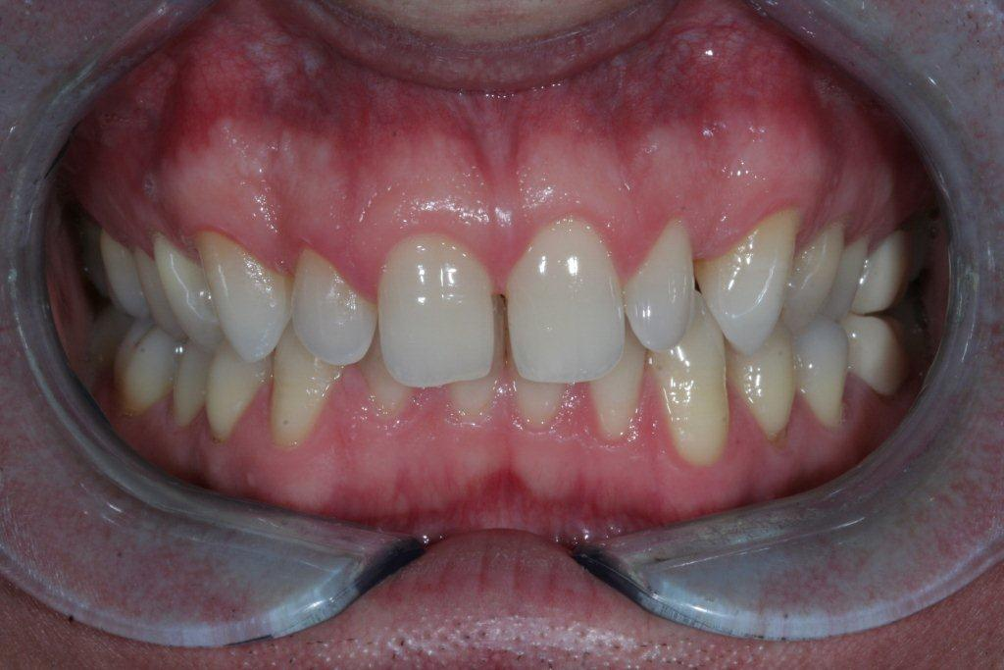

Figure 2 Post-operative

